AWS cloud security with IAM

This project provides a hands on demonstration of AWS Identity and Access Management (IAM) security best practices. Through a step by step walkthrough, I will:
- Create and configure an IAM user and user group,
- Assign granular permissions to the IAM user, and
- Illustrate the security boundaries by demonstrating what happens when an IAM user attempts to perform actions outside their assigned permissions.
- 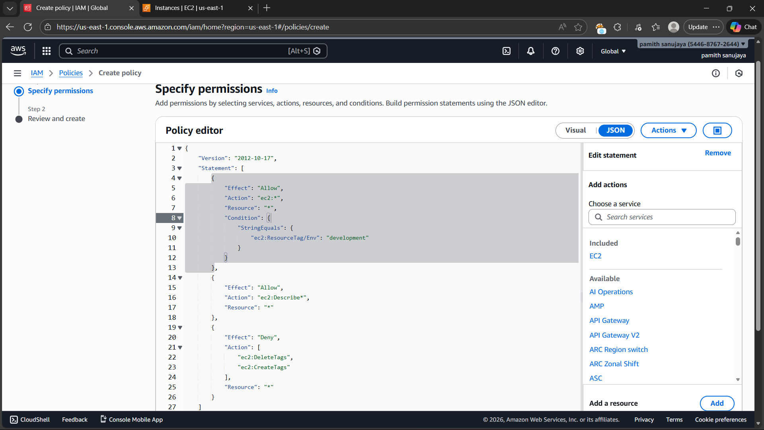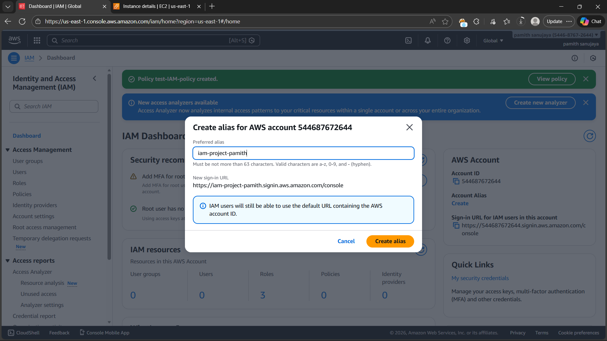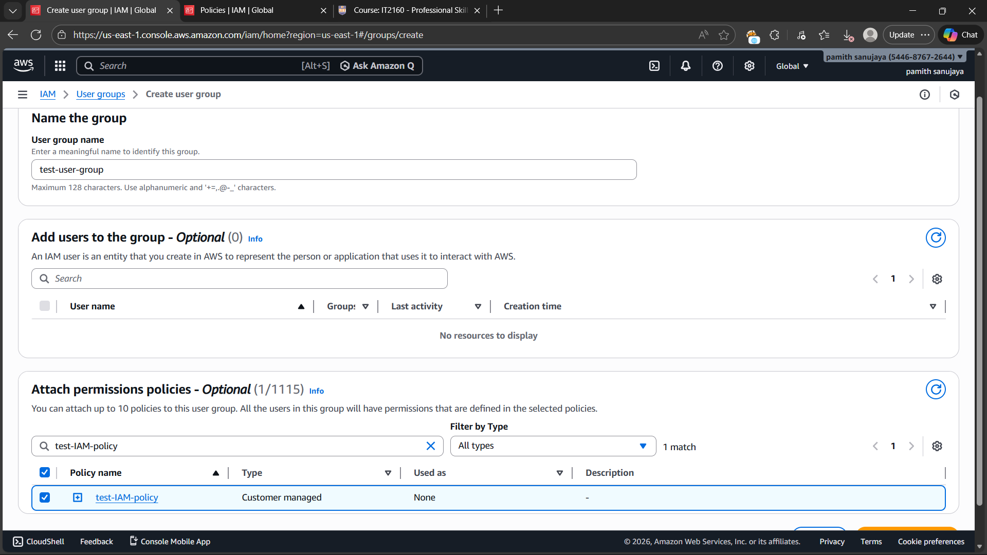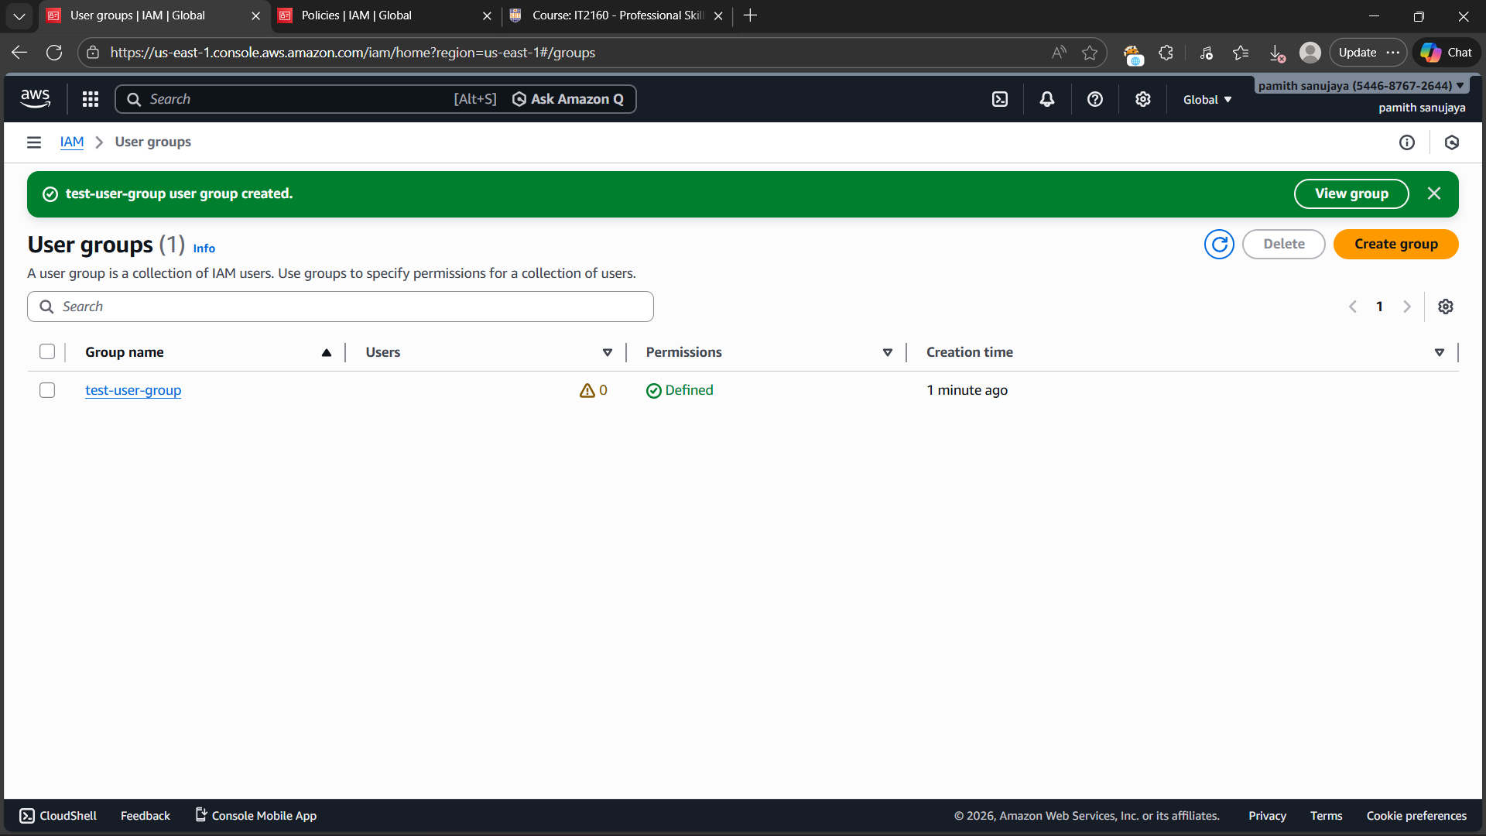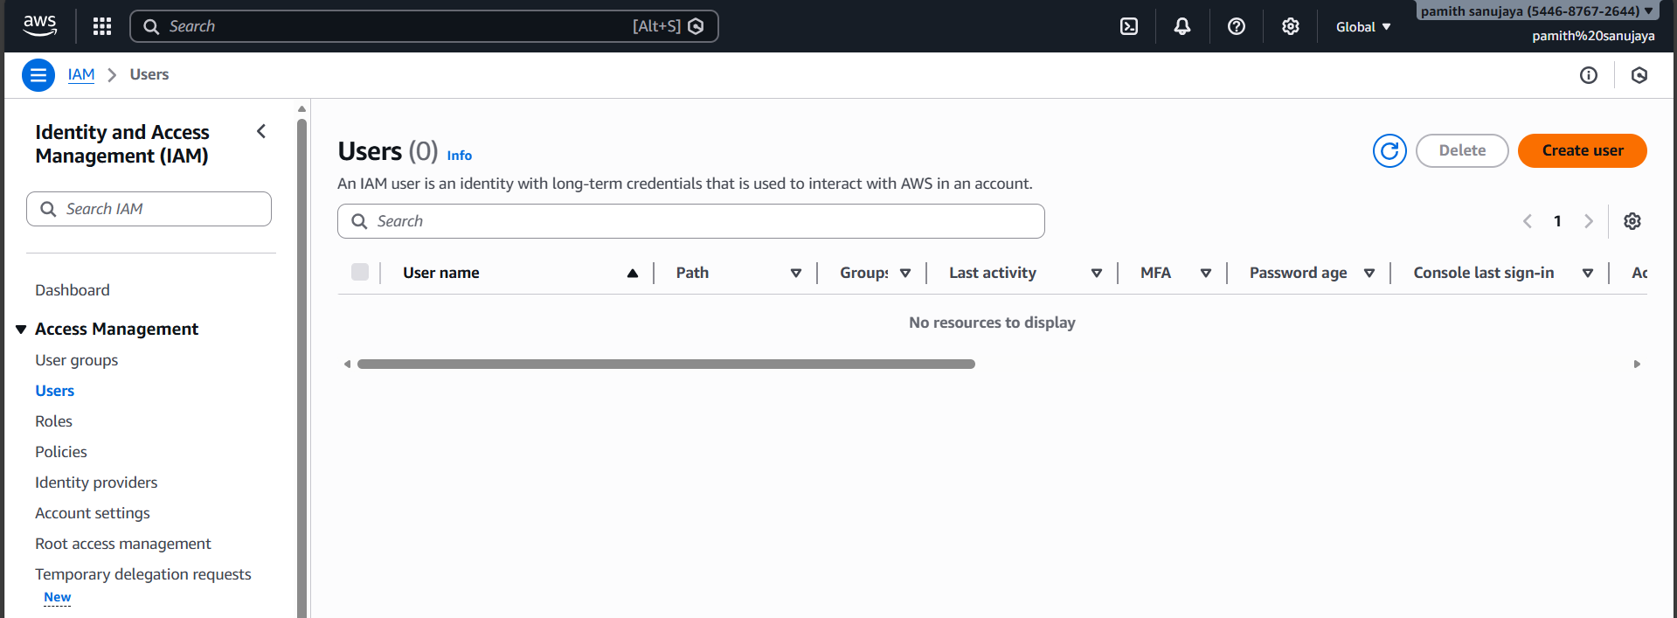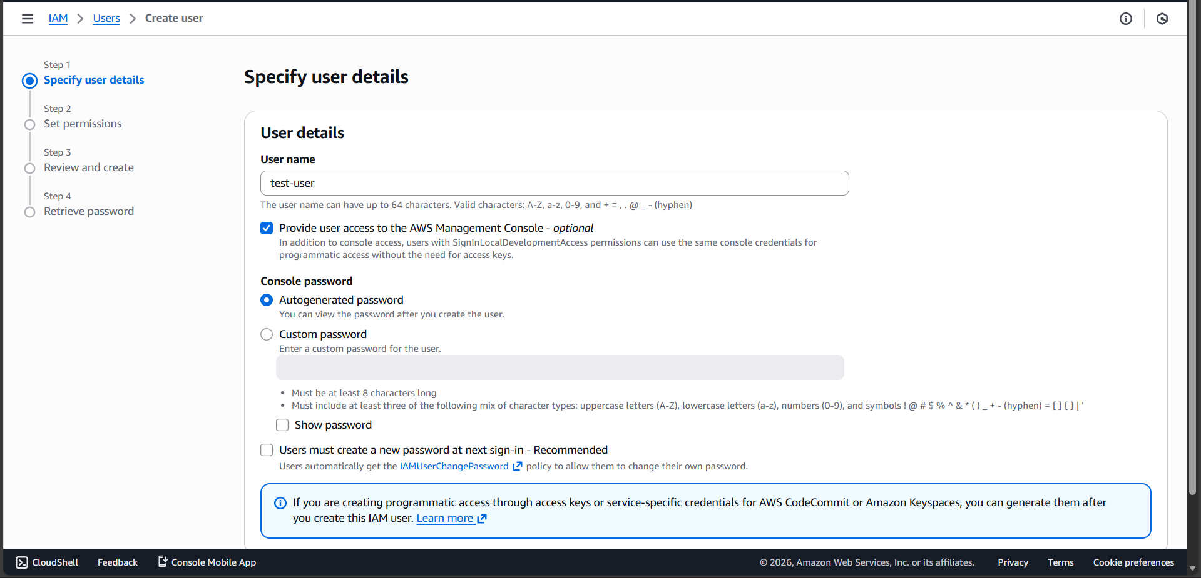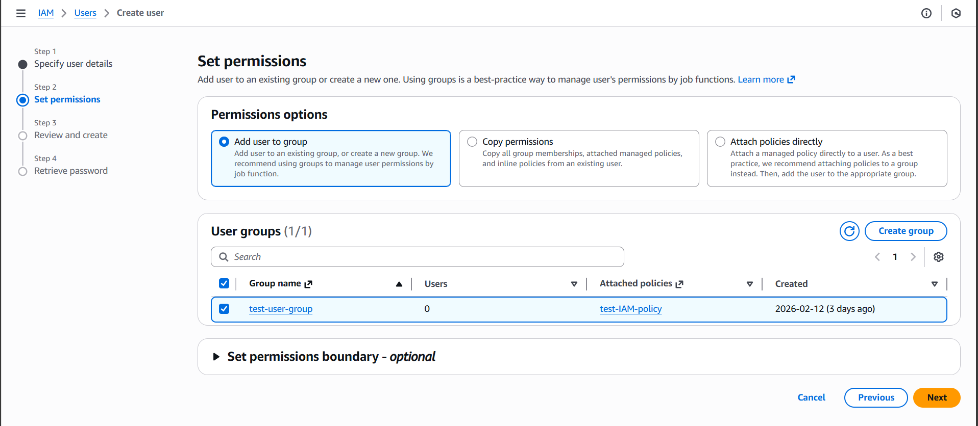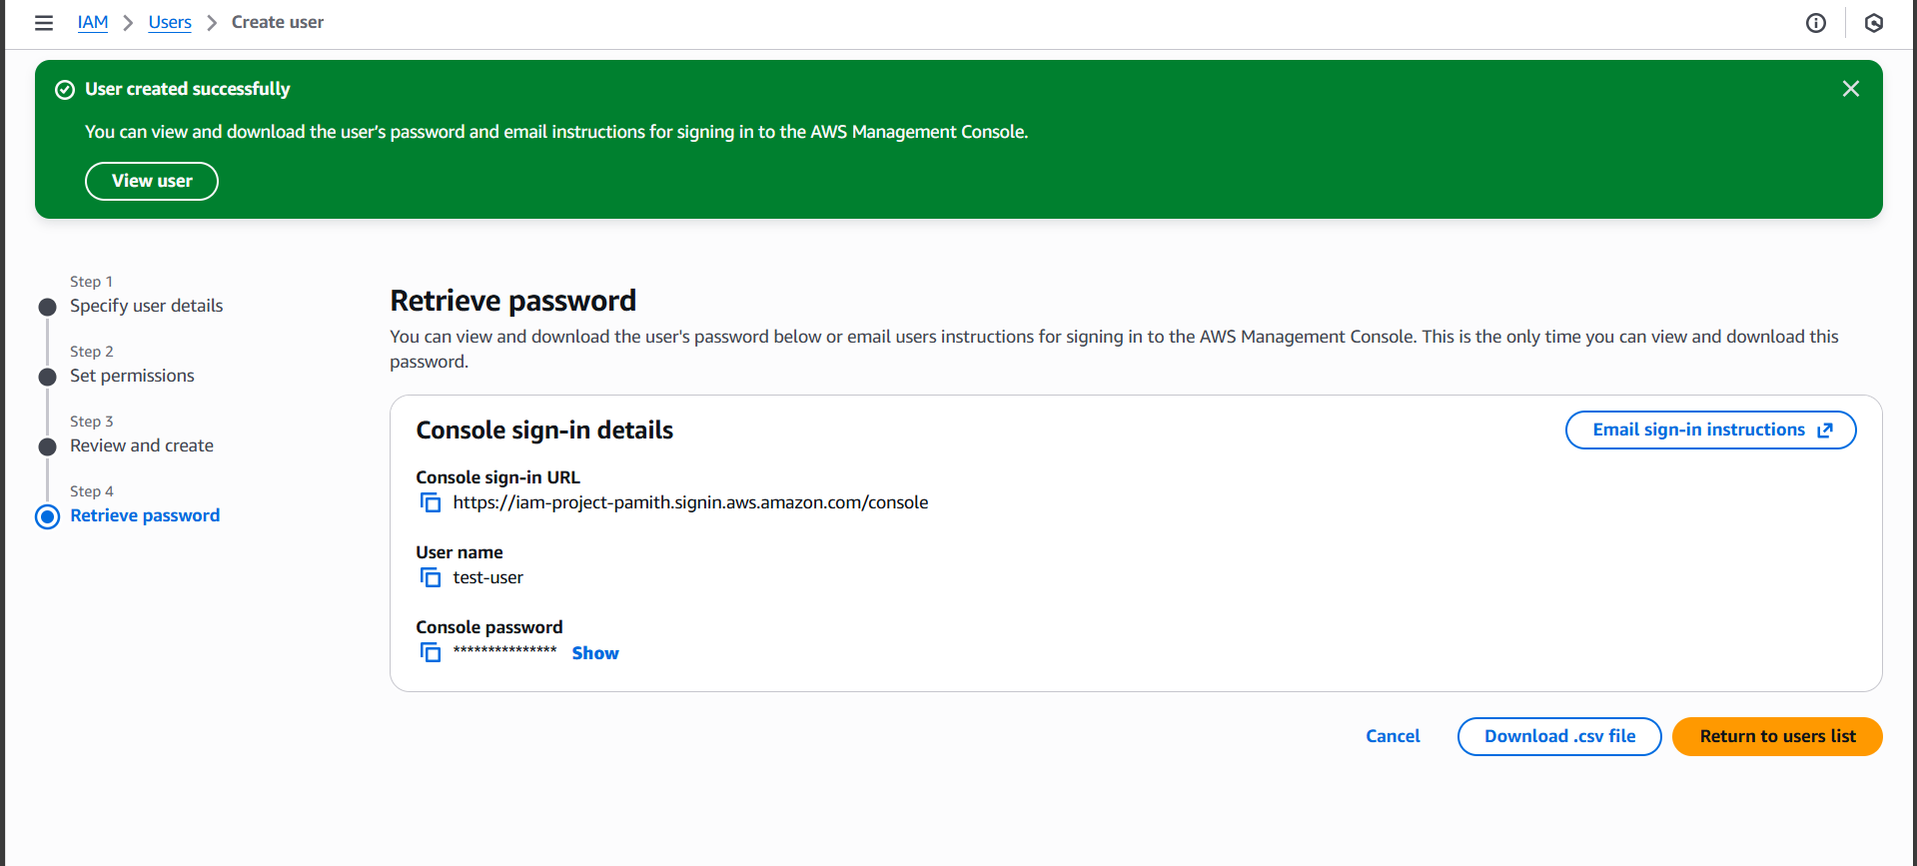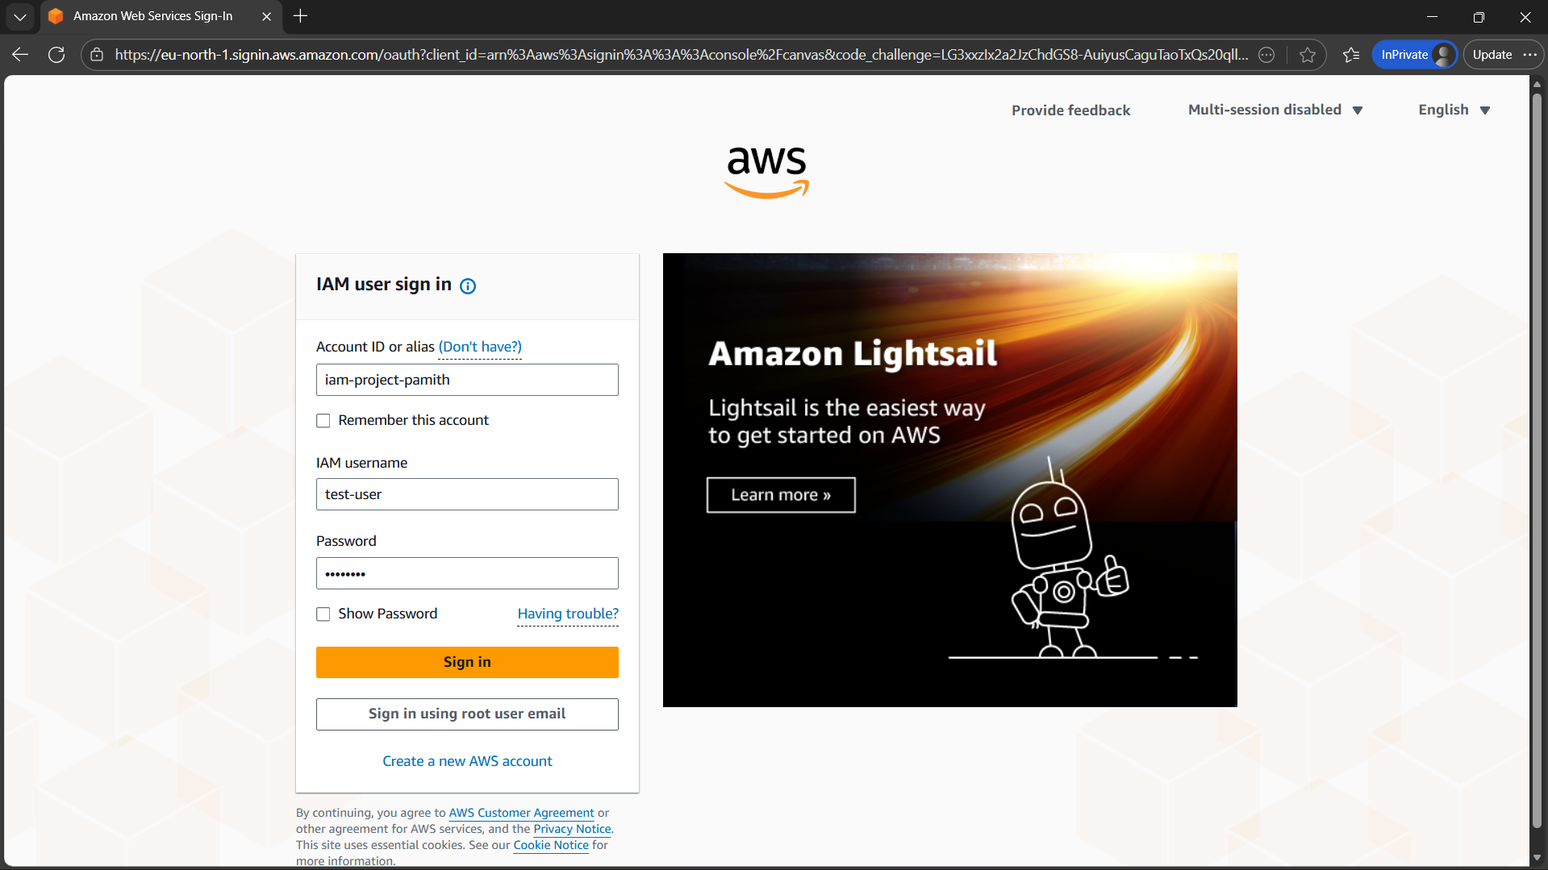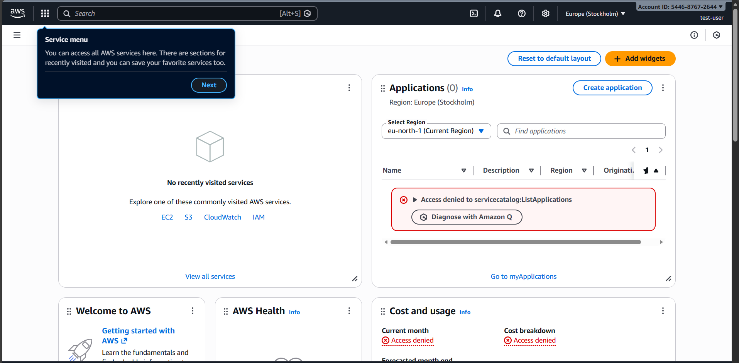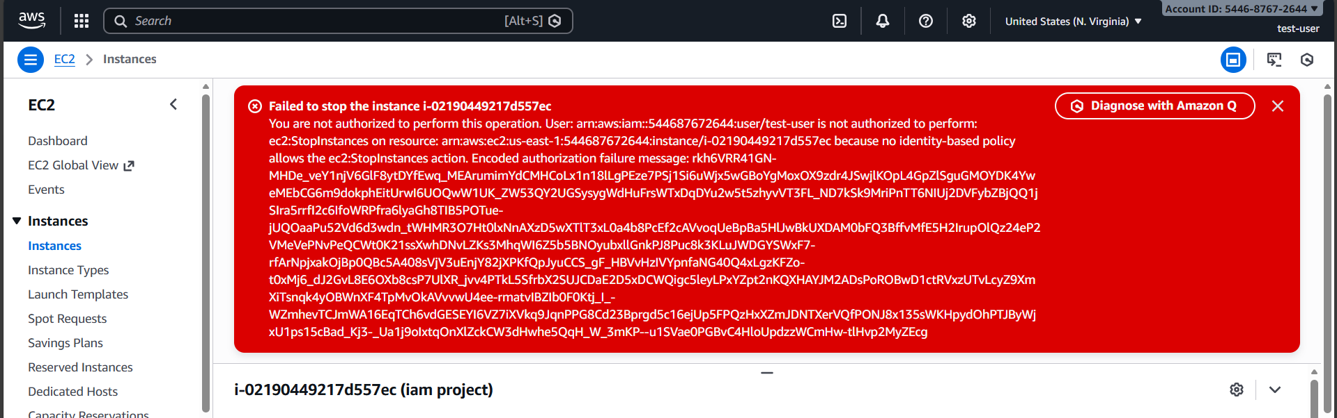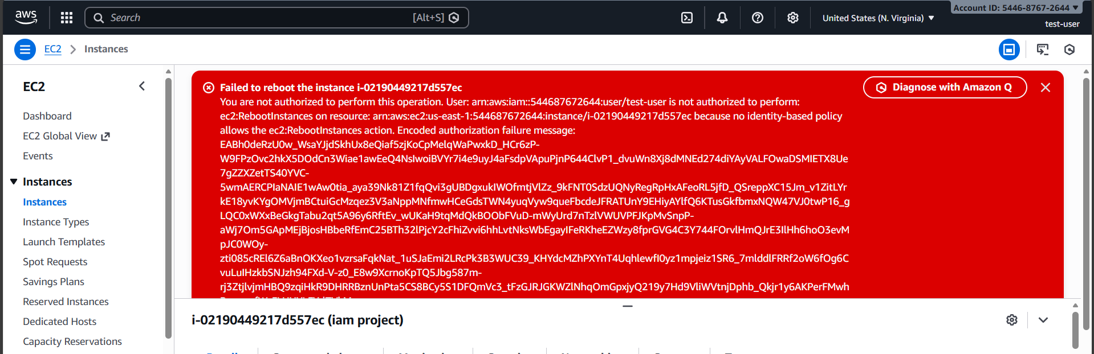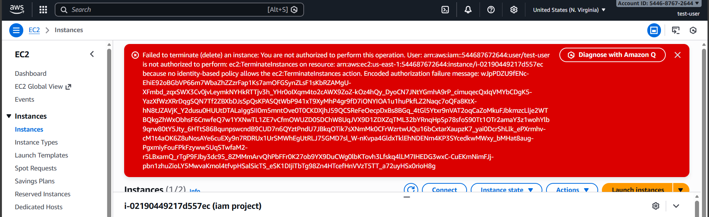
This practical approach highlights the importance of least privilege access and effective permission management in AWS environments.

